

UNIVERSITY INSTITUTE OF COMPUTING

PROJECT REPORT

Amazon clone

Program Name: BCA

Subject Name/Code: Web Desining(24CAH-153)

Submitted by: Submitted to:

Name: Jhuna Kumar Name: Manisha Nagpal
UID: 24BCA10198 Designation: Assistant Professor
Section: BCA – 8 “B” Signature:-------------------

Abstract
This project is a full-stack Amazon clone designed to replicate the essential features of a modern e-commerce platform. It includes user authentication, product listings, cart functionality, order management, and payment integration. Developed using [insert tech stack, e.g., React, Node.js, MongoDB], the application offers a responsive and user-friendly interface. The backend supports secure data handling and API operations, while the front-end ensures smooth navigation and interactivity. This project demonstrates a solid understanding of full-stack web development and provides hands-on experience in building scalable, real-world applications similar to leading e-commerce platforms.

Demo and code

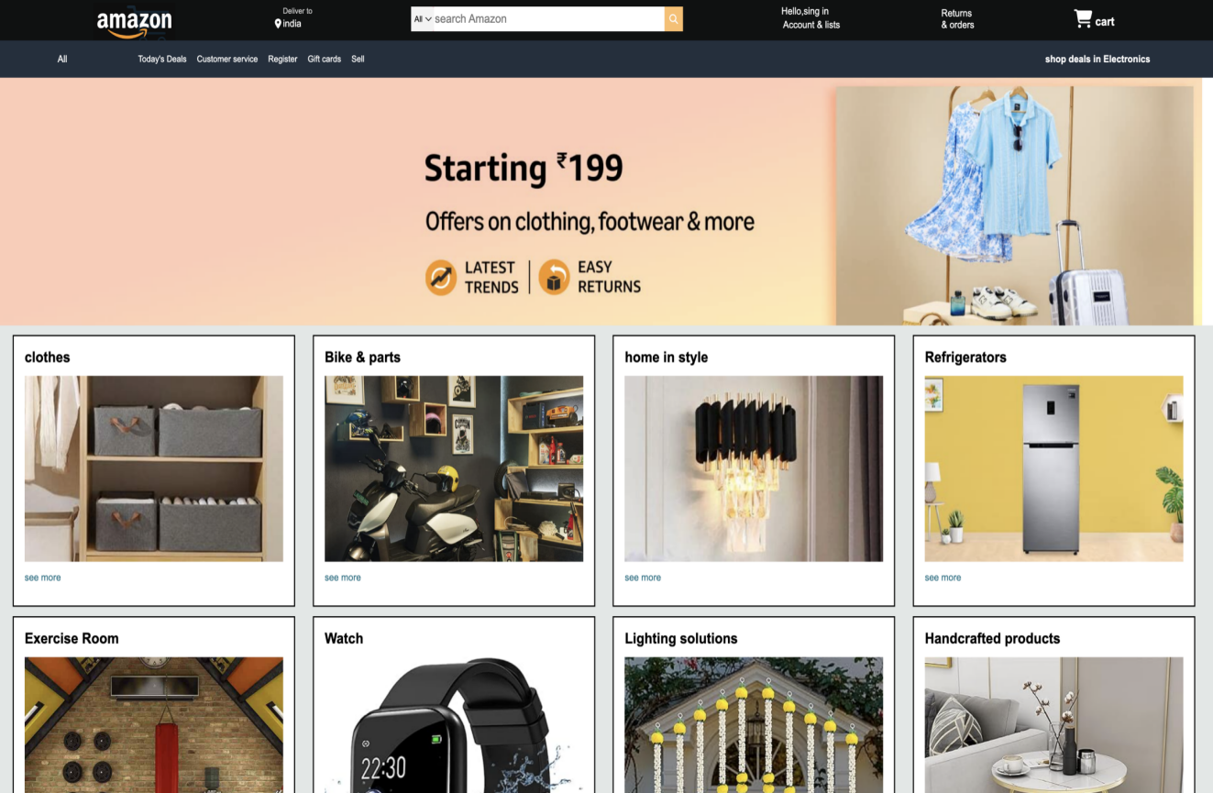

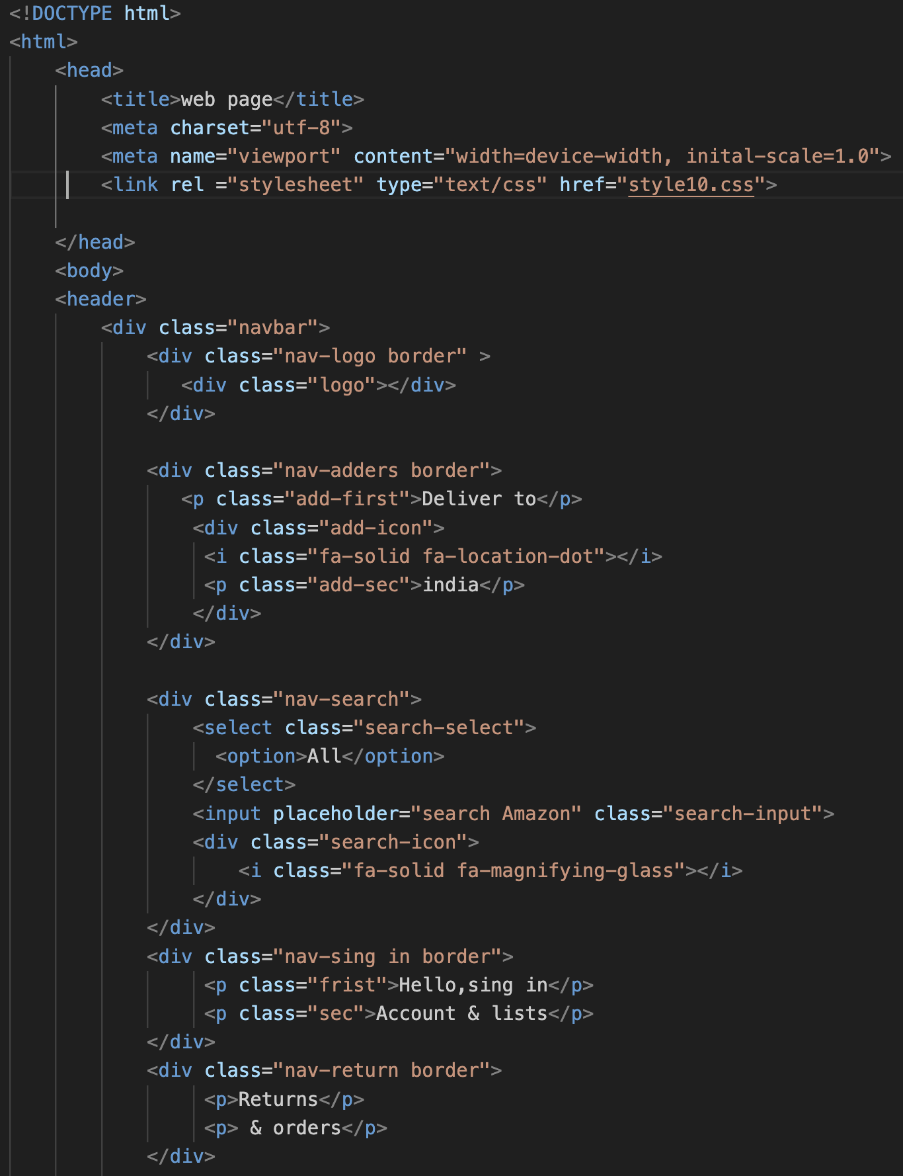

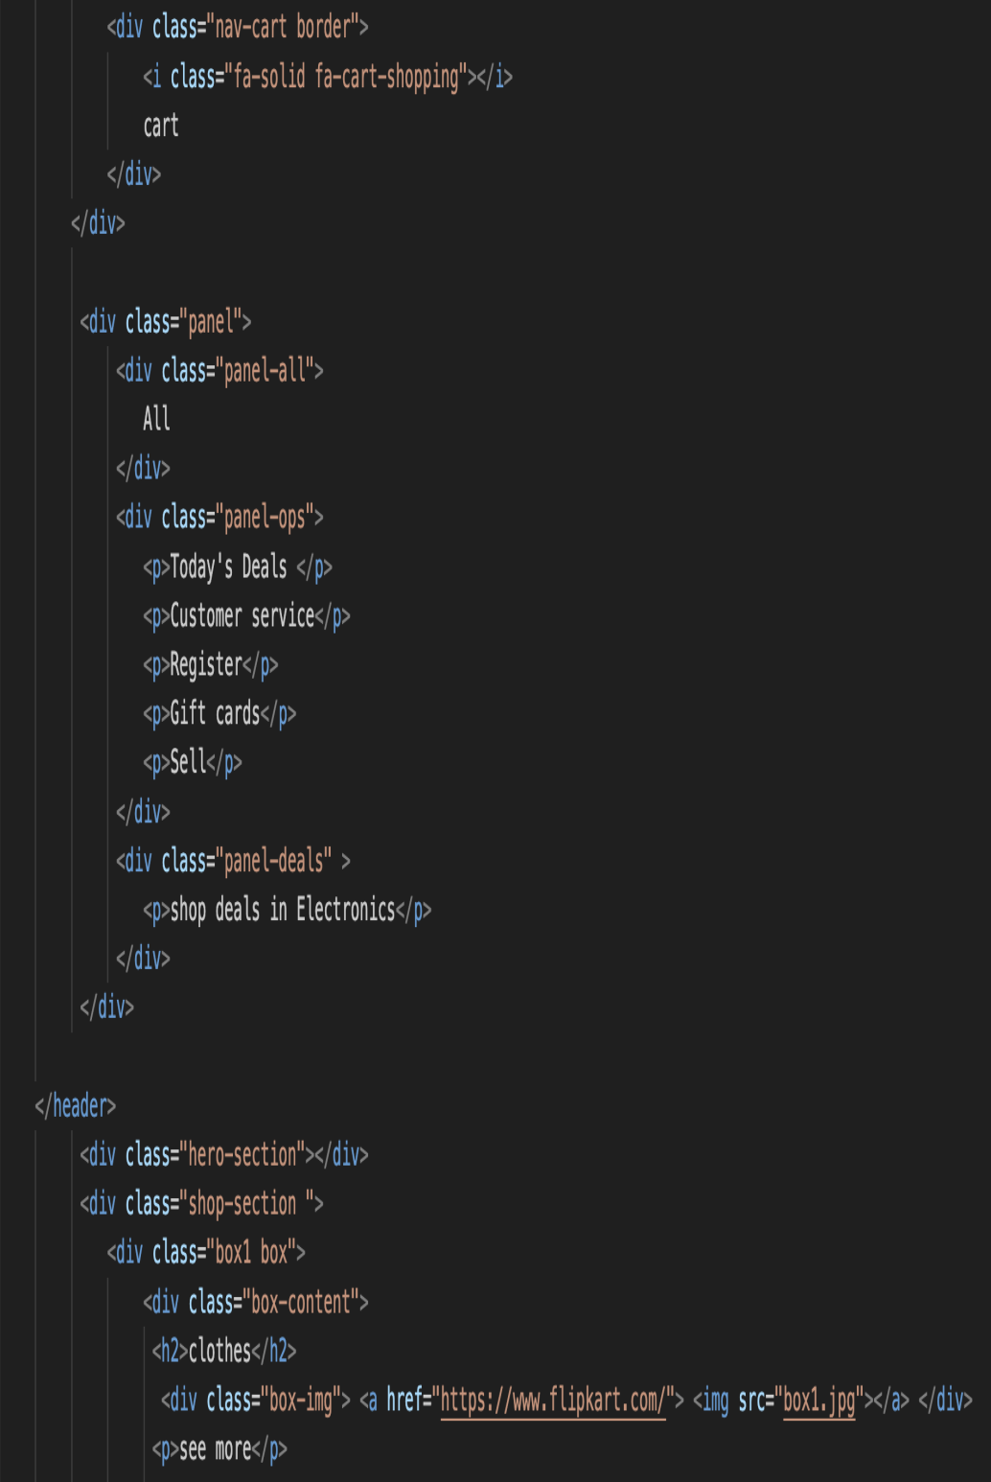

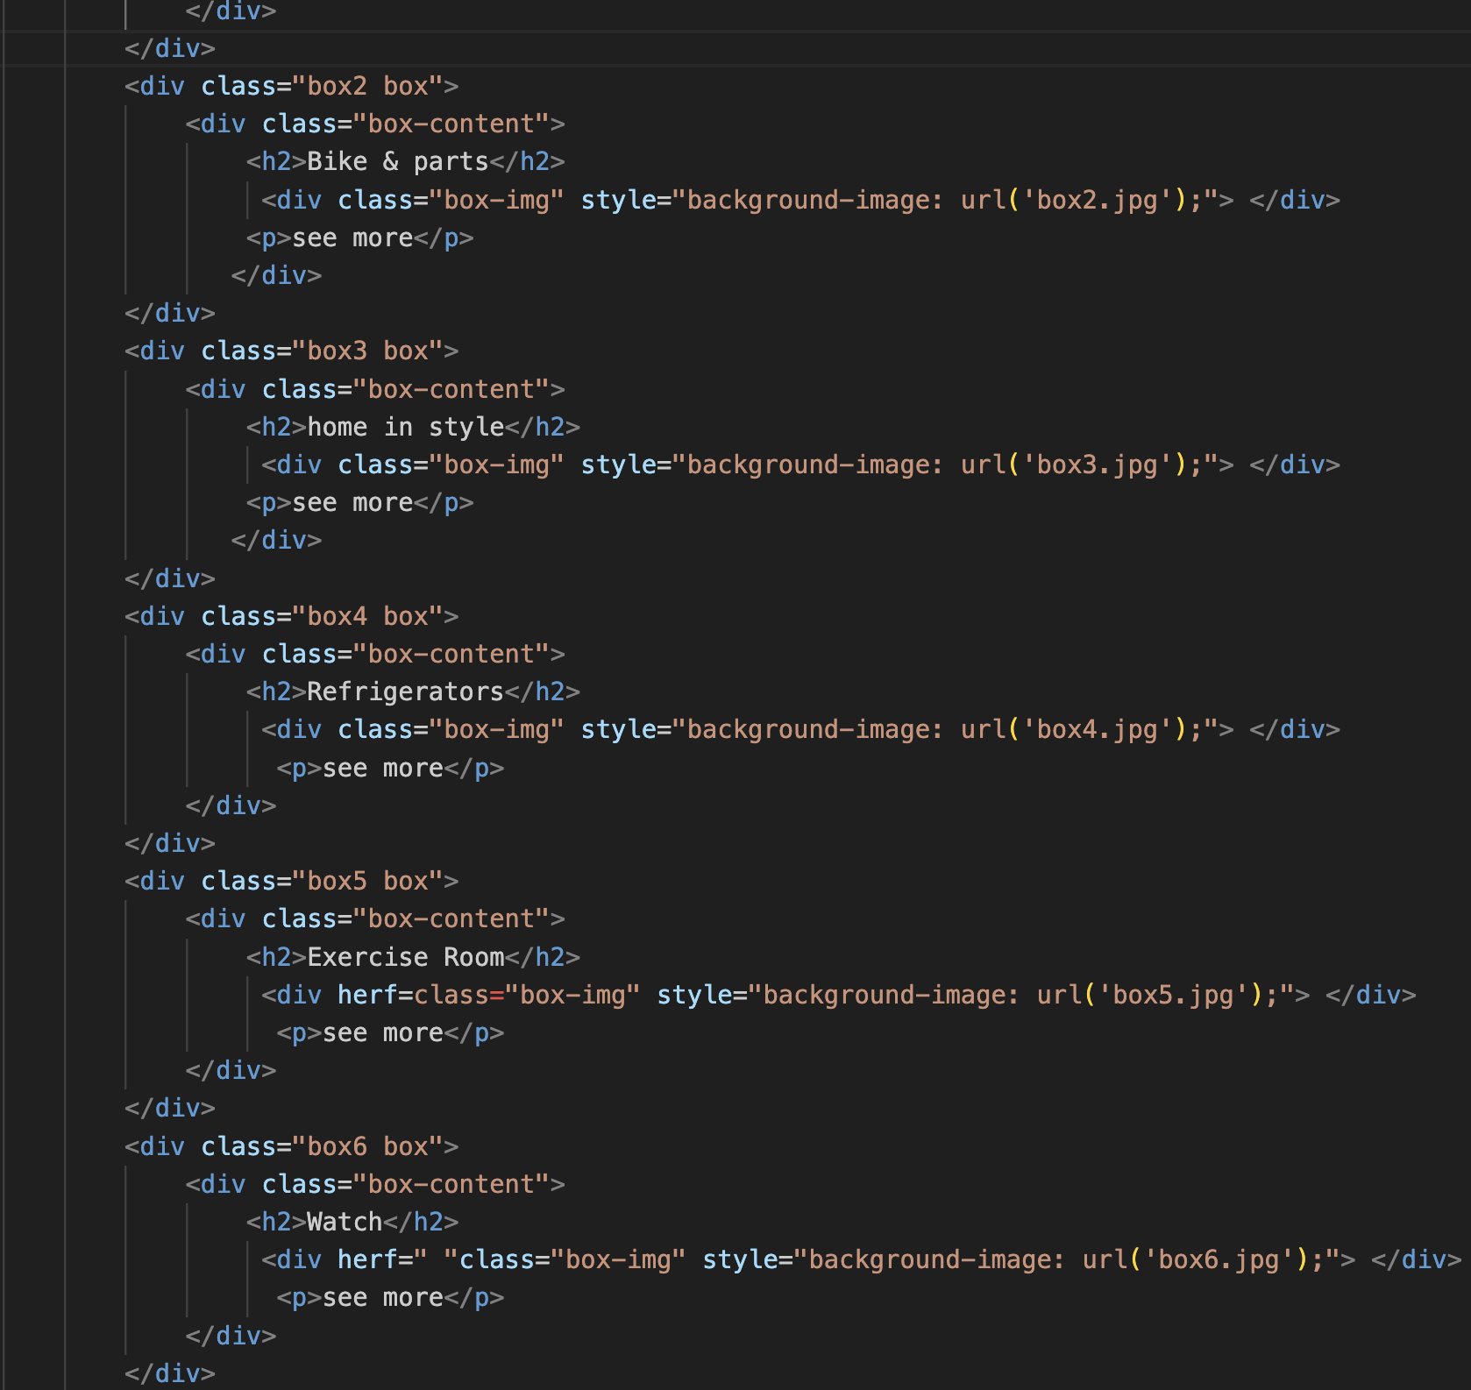

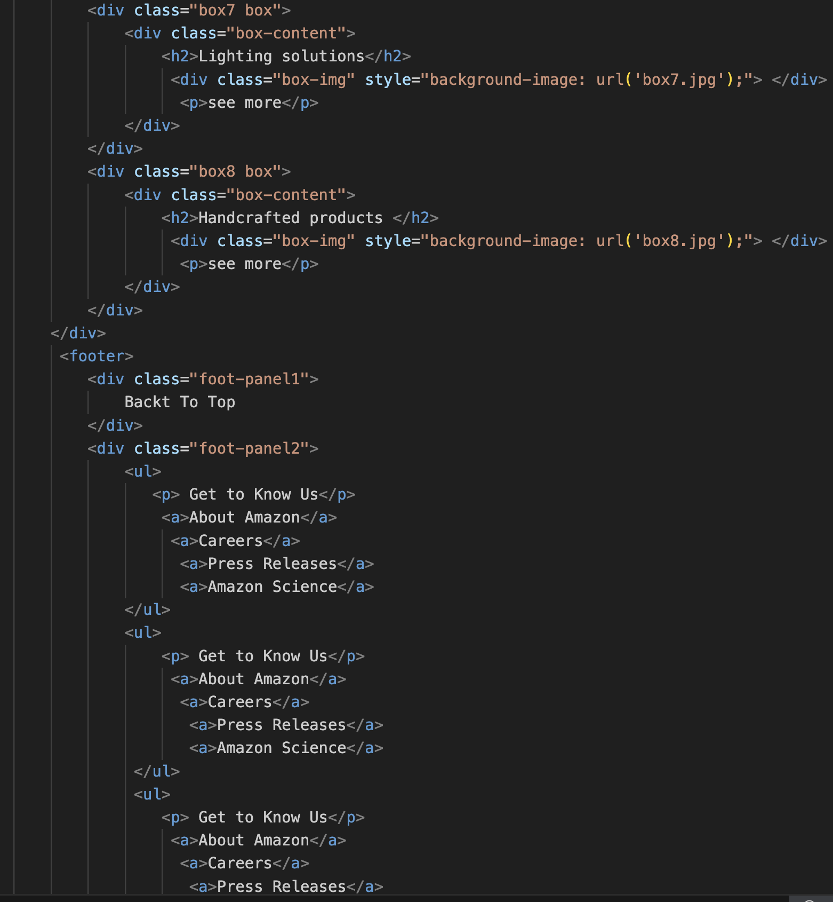

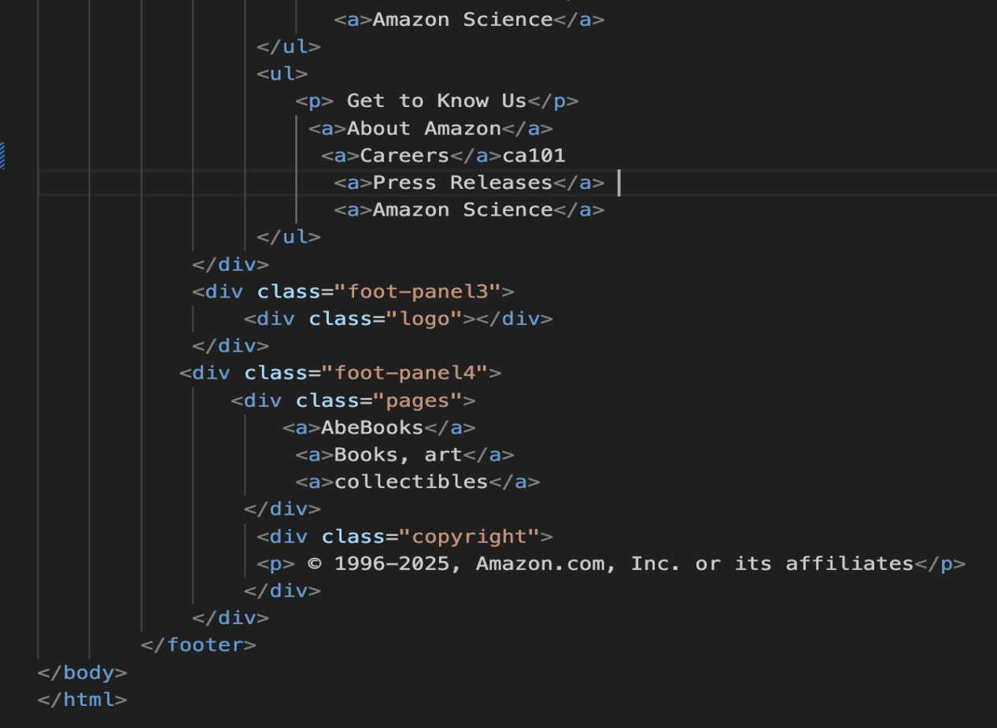

Objectives
. To develop a fully functional e-commerce web application replicating core features of Amazon.
. To implement secure user authentication and account management.
. To design a responsive user interface for seamless browsing across devices.
. To enable product listing, detailed product pages, and dynamic search/filter functionality.
. To create a working shopping cart with real-time updates and quantity management.

. To implement an order placement and checkout system with payment integration.
. To build a structured back end for managing products, users, and orders.
. To gain hands-on experience in full-stack development using modern technologies.
. To understand the workflow of large-scale e-commerce platforms and optimize for performance and usability.
Technologies Implemented

- Frontend:
. HTML & CSS – For structuring and styling the user interface.
. JavaScript – To add interactivity and dynamic content.

. React.js – For building reusable UI components and managing thefrontend state.

- Backend:

Node.js – To handle server-side logic and APIs
. Express.js – As a lightweight web framework for routing and middleware.

Features

- User Authentication
. Sign up, login, and logout functionality
. Password encryption & validation
- Homepage & Product Listings
. Dynamic product cards with images, name, price, rating
.Search bar with real-time filtering
. Categories & filter options (e.g., price, brand, ratings)
. Sorting: low-to-high, high-to-low, newest, etc.
- Product Details Page

. Detailed view of product: description, images, price, rating, stock
."Add to Cart" and "Buy Now" buttons
.Customer reviews & ratings

- Shopping Cart

. Add/remove products
.Change quantity
.Auto price calculation

Development Process

- Planning & Requirements

.Defined core features inspired by Amazon
.Outlined user flows: guest browsing, user signup/login, shopping, checkout, admin operations.

- Project Setup

. Initialized Git repository with proper version control.
. Created project structure for both frontend .
. Installed essential dependencies

- Frontend Development

.Designed UI using for responsiveness.
. Built reusable components (Navbar, ProductCard, Footer, etc.).

- Cart & Checkout Logic

. Built cart logic with add/remove/update functionality.
.Created address input and simulated payment flow.
.Developed order confirmation and order history features.

Conclusion

Building the frontend of the Amazon Clone was a valuable experience that helped me understand how to create a user-friendly and responsive e-commerce interface. I used React to build the structure of the website and added different pages such as the homepage, product listings, product details, cart, and checkout.
I learned how to use React Router to create smooth navigation between pages, and I built reusable components like the Navbar, Product Card, and Footer. The layout was designed to look clean and work well on both desktop and mobile devices, using CSS / Tailwind CSS / Bootstrap for styling (whichever you used).
State management was an important part of this project. I handled product data, cart functionality, and user interactions using React hooks / Context API / Redux (your choice). This helped me understand how to manage global and local state effectively.

